1. 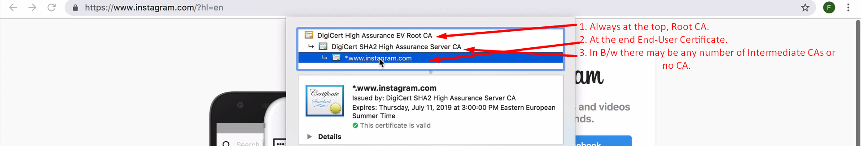
2. The following diagram will explain how the chain of trust is built.
3. 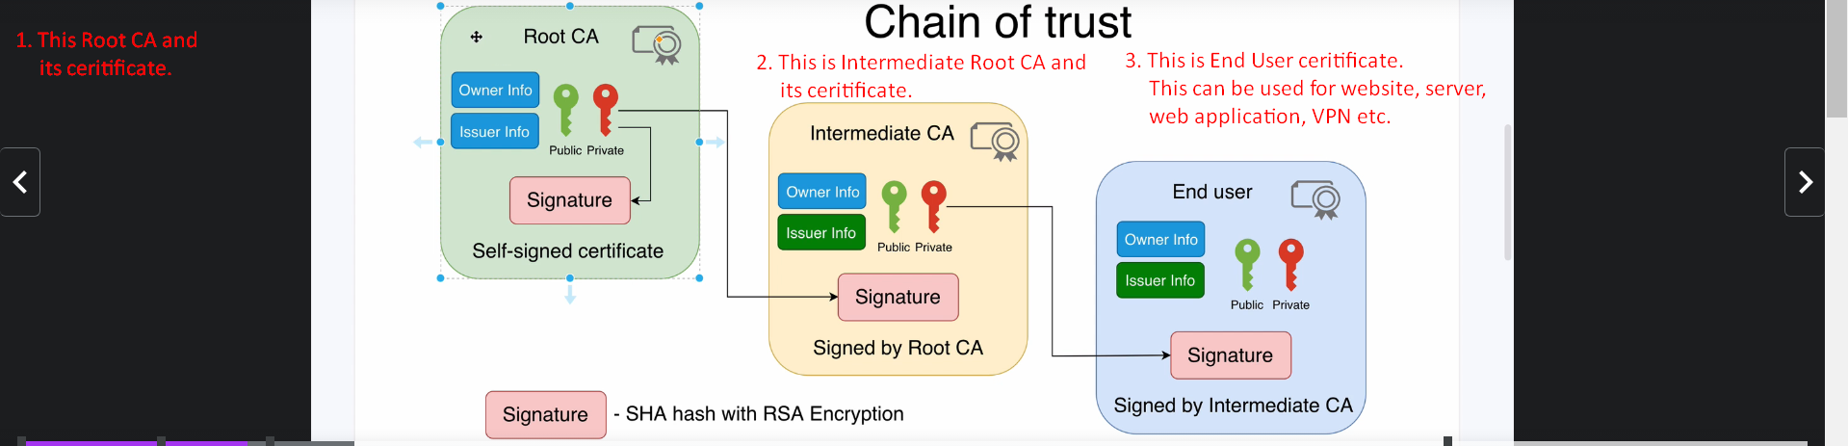
4. Let’s start with Root CA and its certificate.  
   In the following snapshot, after point 3, there are points 8,9. It happened by mistake. Please follow the sequence like this.
5. 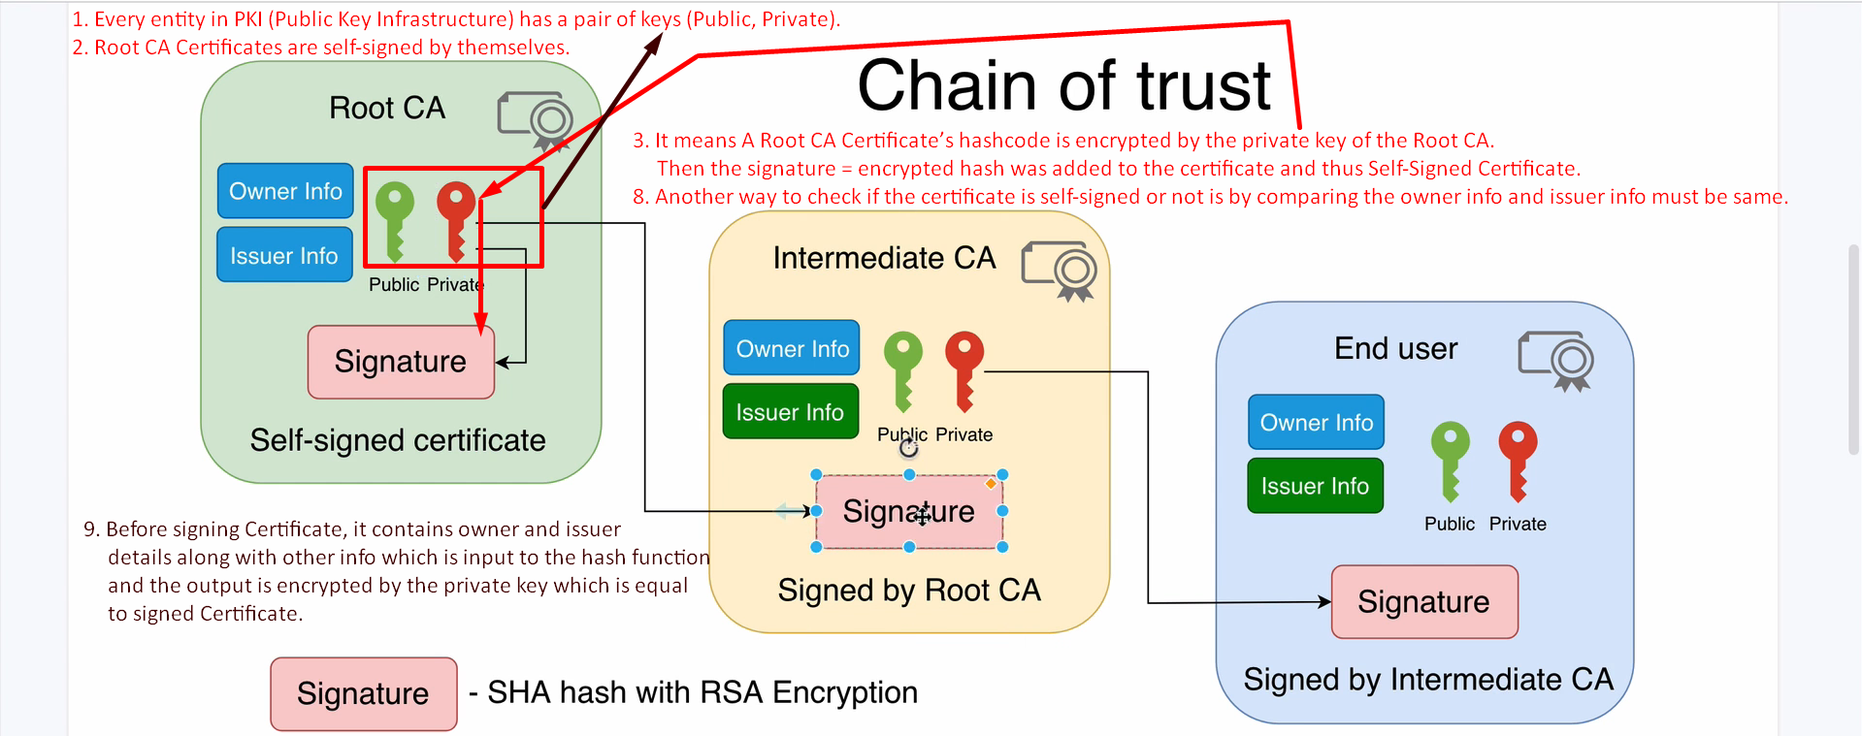
6. About Intermediate CA  
   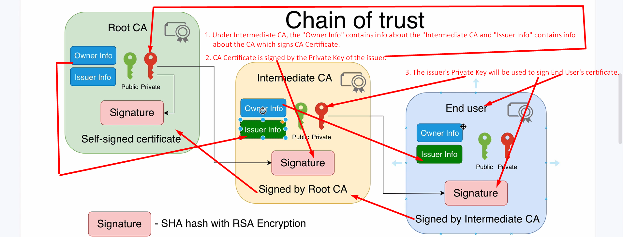
7. This is how the Chain of Trust is built from Root CA Certificate to End-User Certificate.
8. 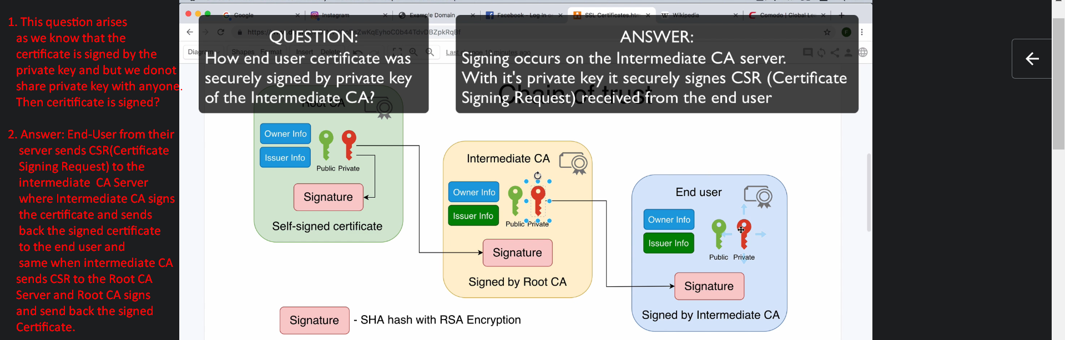
9. Next Lecture:
   1. Verification of a certificate.  
      When you open up a browser, you are presented with End-User Certificate and we must verify that end-user certificate.